The Alcohol and Other Drug Thesaurus (AOD Thesaurus, AODT)
A Guide to Concepts and Terminology in Substance Abuse and Addiction. 3. ed. 2000
Link to thesaurus: https://aodthesaurus.com To this document dsoergel.com/AODThesaurusOverview.docx
A meaningfully structured thesaurus with very broad (nearly universal) subject coverage
10,000 concepts represented through preferred terms plus 7,000 non-preferred terms (synonyms)
Until further notice everything is drug-related (sign on the door of a substance abuse counselor)
The AOD Thesaurus has been designed for a broad range of functions, including
Cross-disciplinary knowledge transfer and synthesis, free-text search, knowledge-based enhancement of AI.
Even after 25 years it still is helpful in fulfilling these functions.
Serves as an example for the meaningful presentation to support users’ grasp and understanding
of Knowledge Organization Systems (ontologies, taxonomies, classifications, thesauri)

Functions. The overarching objective of the AOD Thesaurus is to provide a conceptual map,
a conceptual framework for researchers and practitioners in the interdisciplinary AOD field to
- convey meaning and help with sensemaking; sections of the thesaurus can be read like a text to understand the "lay of the land" of a domain
- help scholars and practitioners in one discipline understand the contributions of other disciplines
- support users in gaining a better understanding of their search topic and in formulating queries for free-text search (including manual or automated synonym and hierarchic query term expansion) and for concept search using a controlled vocabulary
- serve as controlled vocabulary for indexing and information retrieval in database systems, esp. user-oriented indexing (enables searches that would be difficult in free-text search)
- support knowledge-based enhancement of artificial intelligence systems, including machine learning, semantic natural language processing, e.g. information extraction, and inferential reasoning throughout
Structure. The AODT achieves this through emphasis on meaning and conceptual structure. It provides:
- views from multiple perspectives through its faceted structure
- well-structured hierarchies that present concepts in a meaningful arrangement
- copious definitions (scope notes) that can be seen in the context of the parent and sibling concepts
- many cross-references that link the concepts in a dense network.
- many ways in which concepts are expressed in natural languages giving synonyms and near-synonyms.
See the Broad Outline on p. 2, Guide to Browse and Search p. 3, Pointers and References p. 4

The Alcohol and Other Drug Thesaurus (AOD Thesaurus, AODT)
Citation/  Authority | The Alcohol and Other Drug Thesaurus: A Guide to Concepts and Terminology in Substance Abuse and Addiction. 3. ed. Bethesda (MD): National Institute on Alcohol Abuse and Alcoholism (NIAAA); 2000  The AODT was created by NIAAA in collaboration with the Substance Abuse and Mental Health Services Administration Center for Substance Abuse Prevention (CSAP).  SALIS (Substance Abuse Librarians & Information Specialists, https://salis.org  played a major role in initiating and supporting the work on the AOD Thesaurus.
Purpose | A subset of the AODT was used to index ETOH, the Alcohol and Alcohol Problems Science Database,  NIAAA 1971 – 2003, still searchable at https://addictionresearchlibrary.hazeldenbettyford.org
Audience | The AODT is intended for use by researchers and practitioners in the alcohol and other drug field.
Update Frequ. | The AODT is no longer updated; it was last updated in 2000.

AOD Thesaurus Broad Outline
A/B Focus on Alcohol and Other Drugs (AOD)
A AOD use, abuse, and dependence
B Substance or product
C/F Natural science, biomedicine, and psychology
C Natural science
E Concepts in biomedical areas
F Concepts in psychology and thought
G/J Medicine and prevention
G Health and disease
HA Screening and diagnostic method
HJ Treatment method
J Prevention, treatment, and maintenance. health care
L/O Psychosocial and sociocultural areas. Technology
L Social psychology and related concepts
M Social sciences, economics, and law
MW Religion, the humanities, and the arts
N Communication, information, and education
O Technology. safety and accidents
OZ Sports
P/T Demography/epidemiology, history, research methods, discipline,
demographic characteristics
PA Demography and epidemiology
PM History, geography, and the environment
R Research method and research organization
S Field, discipline, or occupation
T Demographic characteristics
V Named entities: Geographic area, language, religious group
VA Geographic area
VR Language
VZ Religious group
W/Z Named entities: Organism, body part, chemical substance
W Living organisms
X Body part
Y Chemical substances by function
Z Chemical substances by structure

Guide to hierarchic browse and search in AODThesaurus.com
Structure
A webpage is a document viewed in a Web browser as one unit scrollable through one-to-many screens.
The AODT is arranged not alphabetically but in a meaningful hierarchy that is presented in four levels:
The very broad division of the hierarchy in six main sections (all on one screen)
The Broad Outline (b-out) (one webpage, all on one screen)
The Detailed Outline (d-out) (one webpage, many screens)
The Full Hierarchy consisting of all concepts in the AODT, presented in two versions
The Quick Hierarchy (qh), showing just one line per concept represented by its preferred term.
Many webpages that correspond to sections of the hierarchy, each webpage being many screens long
The Annotated Hierarchy (ah), showing for many thesaurus concepts a definition / scope note, synonyms, cross-references to other concepts (traditionally labeled as Broader Term (BT), Narrower Term (NT), Related Term (RT))

Navigation, browsing
In each presentation of the hierarchy, each mention of a preferred term, whether in the main line of a term record or in a cross-reference, is followed by one to four links of the types seen above, b-out, d-out, qh, ah, depending on the webpages in which the term appears. Clicking on one of these links goes to the appropriate webpage and positions the page such that the term the user started from appears at the top of the screen:
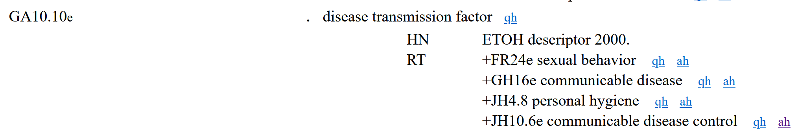
The subscript _{e} after the concept number signifies that the concept is part of the AODT subset used to index ETOH.
Clicking on ah in the line RT +JH10.6e communicable disease control qh ah gets to
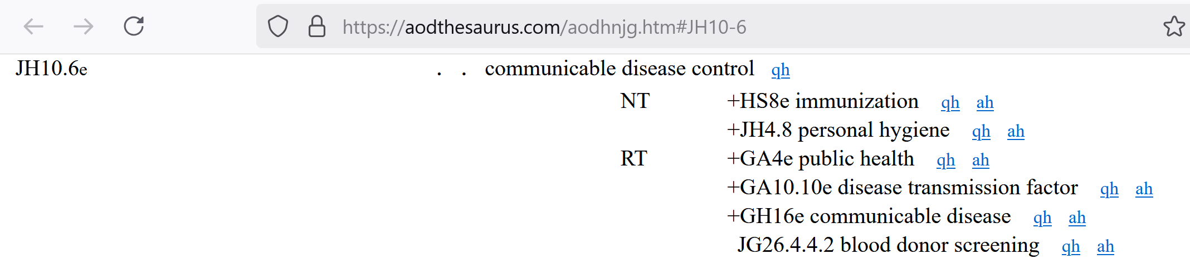
To navigate down the hierarchy, start from the home page. Pick a major section and click on b-out,
pick a main class and click on d-out, pick a subclass and click on qh, pick a concept and click on ah

Search
Search is accomplished through Google search with a site restriction, for example
"communicable disease control" site:aodthesaurus.com
In the result list there are short snippets around where the search string occurs on the page, but when you click on the result link, the webpage displays with the beginning at the top of the screen. To get to the right place on the page, do this
Ctrl+F. In the small box that opens, enter the search string (no quotes)  (Copy search string earlier with Ctrl+C, paste here with Ctrl-V)_ | communicable disease control
In both navigation and search, it is useful to have two browser windows open side by side and/or
when following a link, open the destination web page in a new browser tab.

Pointers and References
Other places where the AOD Thesaurus can be accessed
Long bib record here: https://www.nlm.nih.gov/research/umls/sourcereleasedocs/current/AOD/index.html
http://etoh.niaaa.nih.gov/AODVol1/titlepage.htm] Original website, no longer accessible
https://www.webharvest.gov/peth04/20041014221512/http://etoh.niaaa.nih.gov/AODVol1/aodthome.htm
https://web.archive.org/web/20111015041143/http://etoh.niaaa.nih.gov/AODVol1/aodthome.htm Not as good.
https://evsexplore.semantics.cancer.gov/evsexplore/concept/ncim/C1140162 Hierarchic browse, cumbersome
Warning: The pdf from Google Books is the outdated first edition

Integrated thesaurus databases that include and can be searched for AODT concepts and terms
https://ncimetathesaurus.nci.nih.gov https://ncimetathesaurus.nci.nih.gov/ncimbrowser
https://www.nlm.nih.gov/research/umls/knowledge_sources/metathesaurus/index.html Requires free license.

ETOH, the Alcohol and Alcohol Problems Science Database, NIAAA 1971 – 2003
Searchable with descriptors from the AOD,T free-text, and Advanced Search at
https://addictionresearchlibrary.hazeldenbettyford.org/etoh
This is an interdsciplinary database indexed with the AODT. It is still useful to search to get a sense of a topic across disciplines and terminology to use in free-text search. Results reported in older literature need to be checked, but relevant older papers can serve as the starting point for a forward citation search (possible even in Google by searching for a title).

Reviews
Fugmann Robert 1994. – Review of The Alcohol and Other Drug Thesaurus.
Knowledge Organization. 21(1994)3,p.163-165.
Weglarz, C. 1995. Alcohol and Other Drug Thesaurus. Book Review
Journal of Studies on Alcohol 56, no. 2 (March 1995): 254–55. https://doi.org/10.15288/jsa.1995.56.254.
Chan, Margy 1995.. The Alcohol and Other Drug Thesaurus. Book Review
Contemp.Drug Probl. 22(1) (1995-03-01): 159–61. https://doi.org/10.1177/009145099502200112.
The AOD Thesaurus is listed first under Further Readings in
Manoleas, Peter 1997. Introduction to Addiction Studies. A Curriculum Reference Manual.
Addiction Technol. Transfer Cntr UCSD School of Medicine, 1997. 600 p. https://apofla.com/dl/exams/full.pdf
Topic Three. Concepts and Terminology, p. 94:” a " comprehensive resource tool, reflecting the interdisciplinary nature of alcohol and other drug (AOD) research and practice, …."

Background reading
Soergel, Dagobert. (2008). Digital libraries and knowledge organization systems
In Kruk, Sebastian, ed. Semantic Digital Libraries. Springer 2008; (pp. 9 -39). www.dsoergel.com/NewPublications/SoergelDigitalLibrariesandKnowledgeOrganization.pdf
A practical introduction to knowledge organization with many examples. Does not cover the use of knowledge organization systems in artificial intelligence, machine learning, and semantic natural language processing, such as information extraction.

For the C source code of the AODT software email ds@dsoergel.com. A pdf version of the AODT 3. ed is in preparation

